

Capstone Project Submission Form
These projects afford students an opportunity to apply their technical skill and knowledge of engineering principles to the development of a complex, team-oriented software project, system, or device. As they work on their capstone project, students have the opportunity to manage a project from beginning to end, learning how to deal with unexpected outcomes along the way. An excellent training ground for working in industry, the capstone project mirrors the type of experiences graduates will face when they begin their careers in engineering.

Company Name: Center for Cognitive Ubiquitous Computing (CUbiC)
Project title: Wireless Haptic Belt

Name of the industry advisor: Dr. Sethuraman Panchanathan and PhD students Sreekar Krishna and Troy McDaniel.

Project description:
The Haptic Belt is a vibro-tactile presentation device, worn around the waist, that can be used as an alternate form of information communication (compared to the traditional forms that include vision and audio) through the use of touch. Haptics is a growing area of research in human machine interaction and communication. At CUbiC, we have developed a Haptic Belt that is a wired version and requires that a laptop be carried at close proximity to the device. As part of this capstone project, we would like to convert the same into a wireless version. The design project would concentrate on hardware and software development towards the wireless belt.
The hardware part involves the construction of a replica vibrotactile belt with 7 vibrators that are controlled via a microcontroller. (CUbiC has all the necessary resources to allow the development of firmware on Microchip microcontrollers.) The microcontroller would then be interfaced with Bluetooth transceiver module that will be mounted on the belt as part of the wireless conversion. The interface between the microcontroller and the Bluetooth module needs to be designed and implemented by the capstone team.
The software side of the project necessarily consists of designing multithreaded applications on Windows OS using Visual Studio development environment in C++ and/or C# languages. The threaded applications will provide opportunity for other software to send control signals to the belt via Bluetooth serial channel.
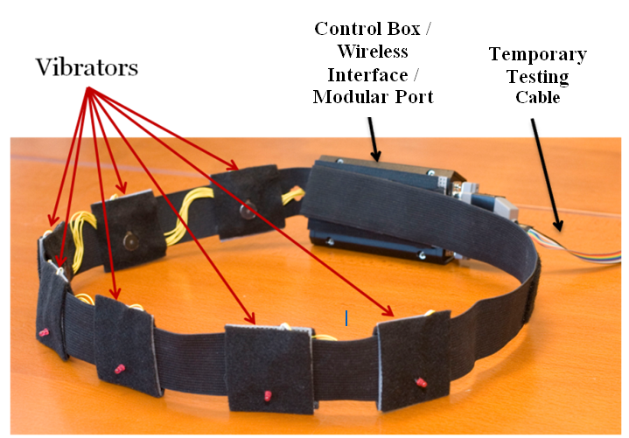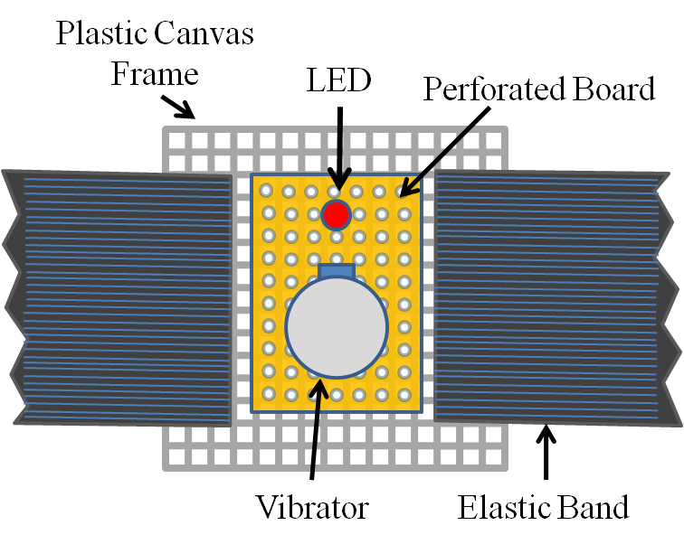
Figure: a) Proposed Haptic Belt with wired connection that needs to be converted to wireless version. B) Individual vibrator elements of the Haptic Belt.
A demonstration of the existing Haptic Belt (shown in the figure above) will be done at the beginning of the semester to the students and explanation on the requirements for the wireless version will be discussed in detail.

Deliverables:
First semester: At the end of the first semester, the students would be required to develop the replica Haptic Belt along with the design of the firmware for microcontroller communication with Bluetooth and microcontroller communication with vibro-tactile actuators. Some of the features to be included in the firmware would be control of
- Vibration patterns
- Vibration duration
- Vibration intensity, and
- Haptic Belt status (Battery level, vibrator tests, communication signal strength, etc)
Second semester: At the end of second semester the students would be required to integrate the software side of the project so that serial communication from a desktop/laptop computer can be sent to the belt to actuate the vibro-tactors. The computer side program has to be multithreaded so that the communication aspects are all handled by one thread while other threads are available for information processing.

